**I IRevolution: A Data –driven Exploration of Apple’s iPhone Impact in India**

**Submitted By**

**Team Members**

**1.ANBARASI M C97E0BDC0032434AB654B6531CF2414D**

**2.DHARSHINI A C454805CE86B7ECBDAA4ACF28CA187FD**

**3.DIVYA M A5339285B71F37F96914B306A9F739CF**

**4. KALEESWARI T 06912CEB237FA7ABFEA4BB95DC7FD53B**

**GUIDED BY**

**Dr.D.ARUMUGAKANI**

**(Assisdent Professor)**

**DEPARTMENT OF MATHEMATICS**

**Sri Meenakshi Government Arts & Science College For Women(A)**



Project Report Template

**1. INTRODUCTION**:

**1.1 Overview**:

Apple has a special chance to increase its market share and

Develop a significant presence in India thanks to the country’s large

Population and rising smartphone adoption.

Already accessible, this research aims to go beyond conjecture

and anecdotal evidence in order to develop a thorough knowledge of

the effects of the iPhone.

This study will offer in valuable insights into the transformative

infect of the iPhone on India’s technological landscape and the lives of

its consumers by using advanced analytics techniques and analyzing

large datasets.

**1.2 Purpose**:

Apple’s decision to manufacture iPhones in India is a robust

alignment with the Indian government’s ‘Make in India ‘ initiative. By

engaging local suppliers like Foxconn and Wistron, Apple is contributing

to the nation’s industrial growth, inculcating technological innovation,

and creating thousands of jobs.

**2.PROBLEM DEFINITION & DESIGN THINKING**

**2.1 Empathy**:

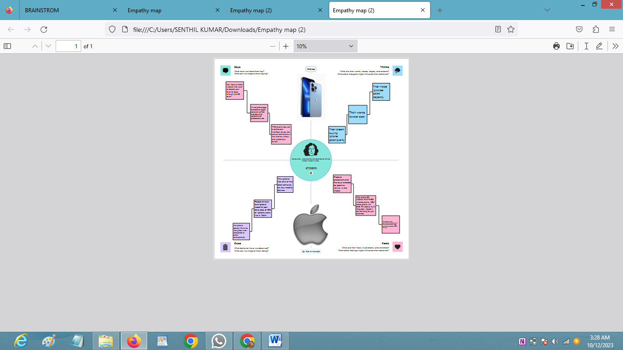

I

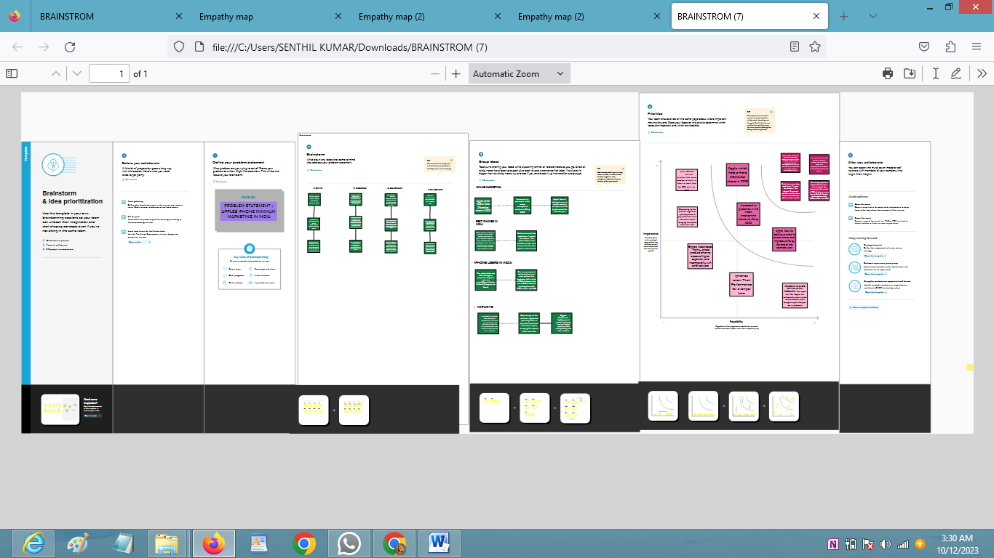 **2.2 IDEATION & BRAINSTROMING MAP**

**3. RESULT**

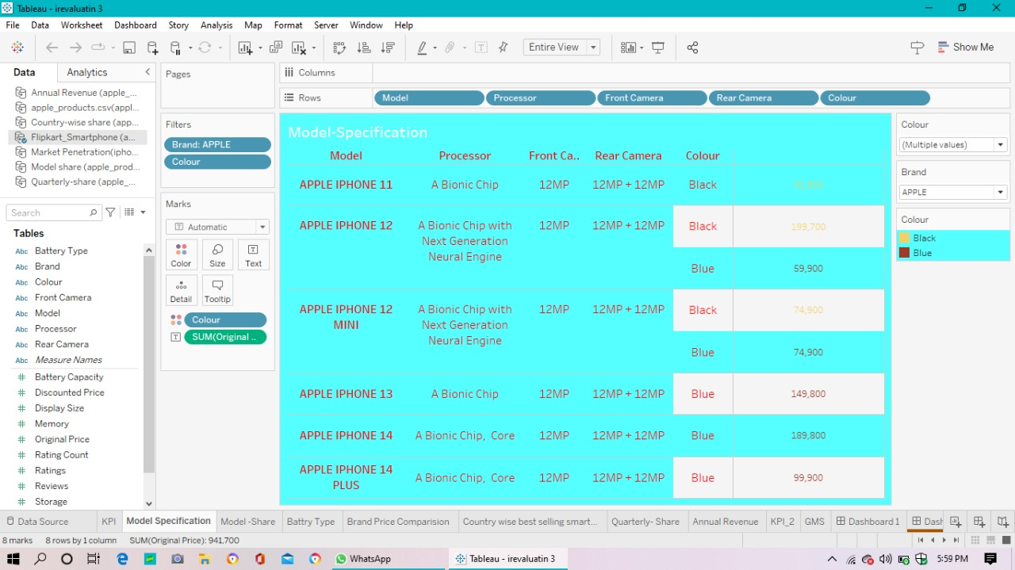

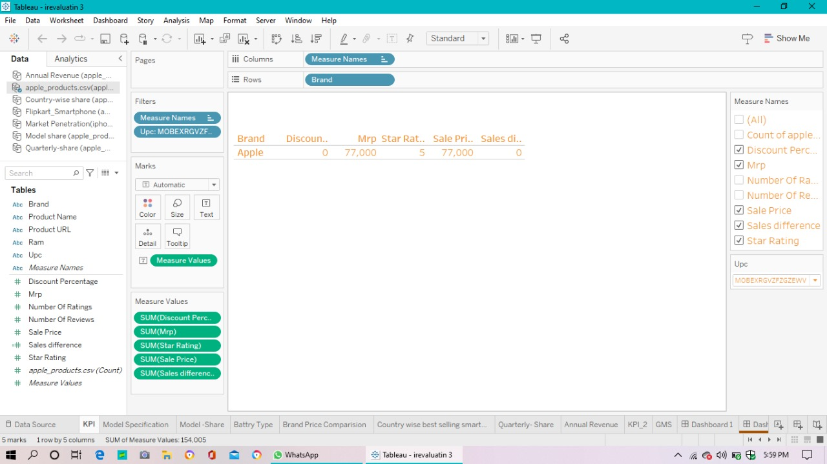

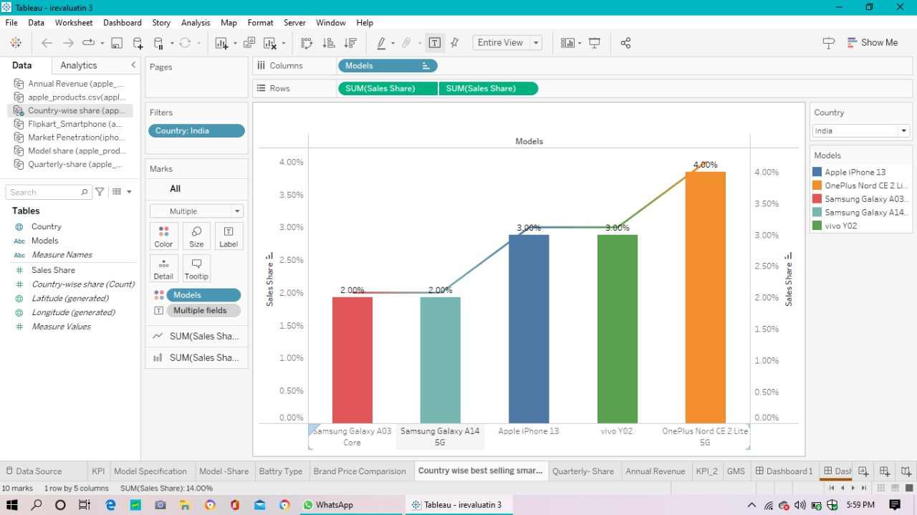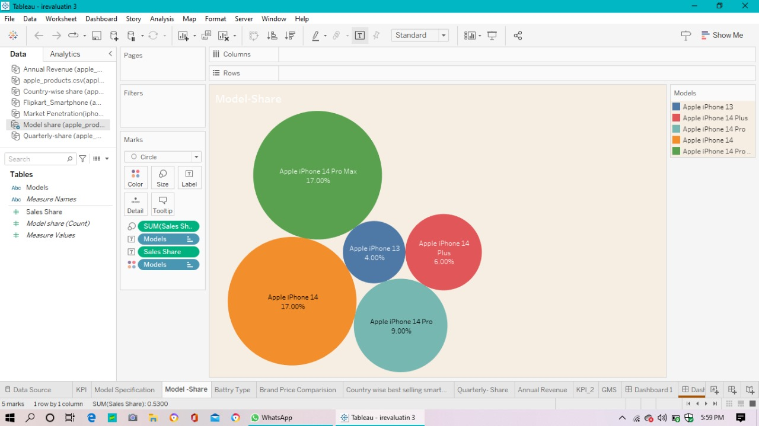

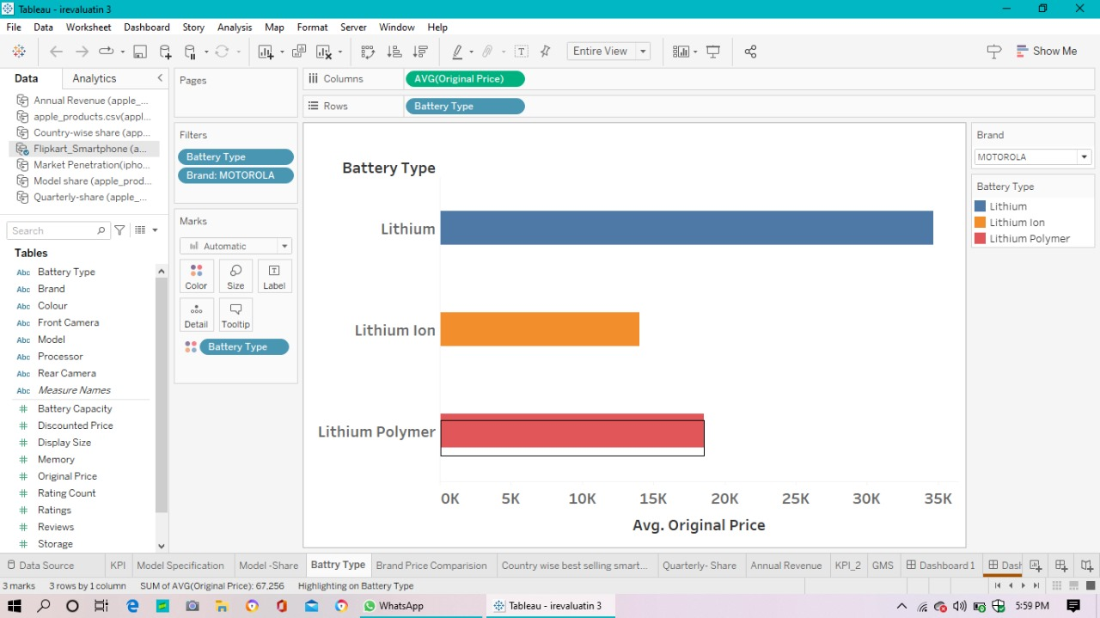

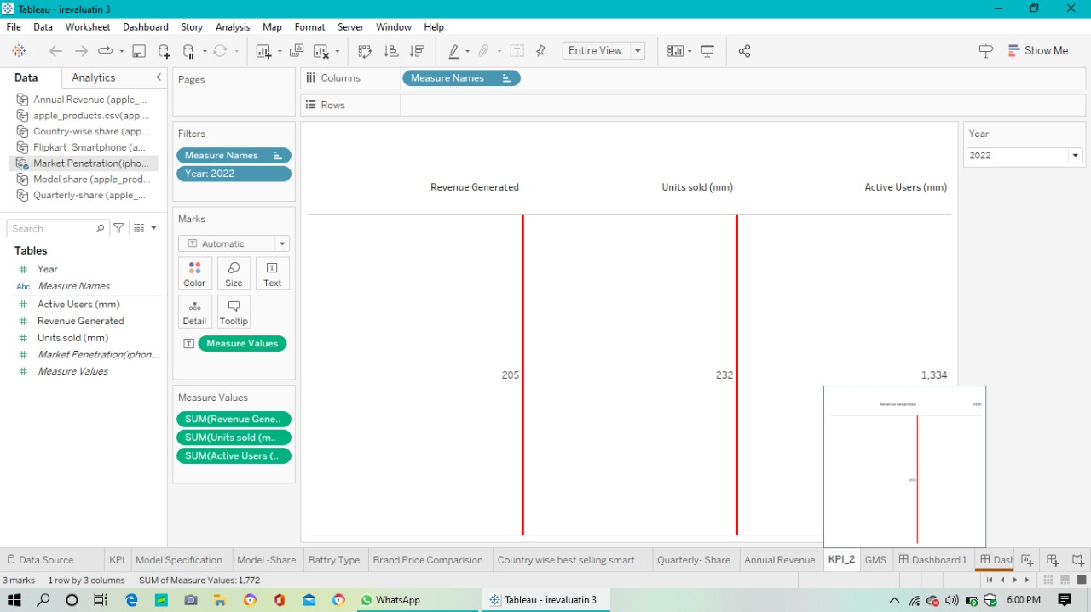

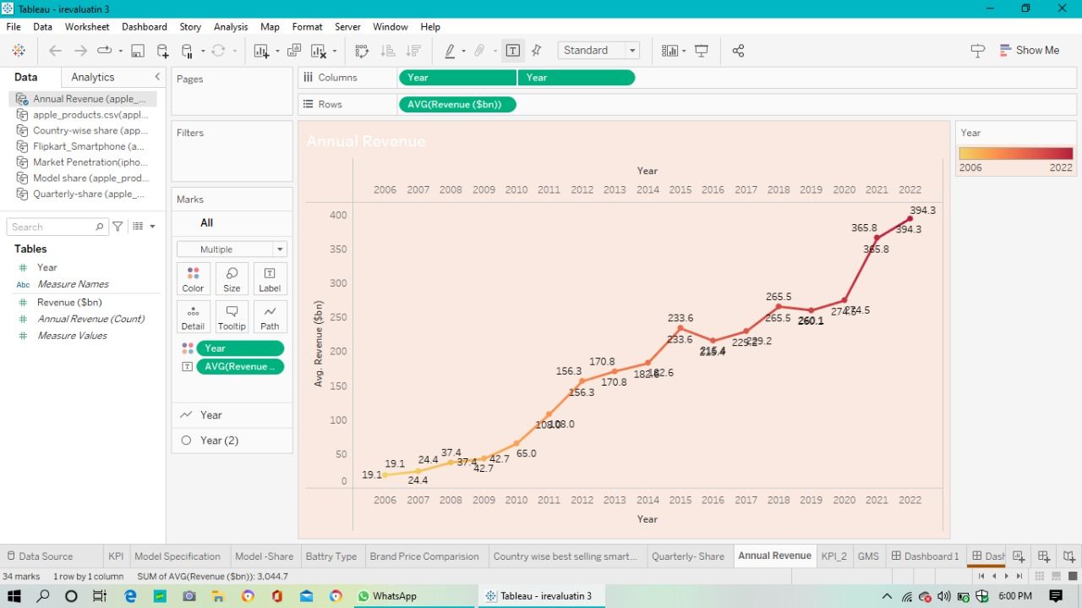

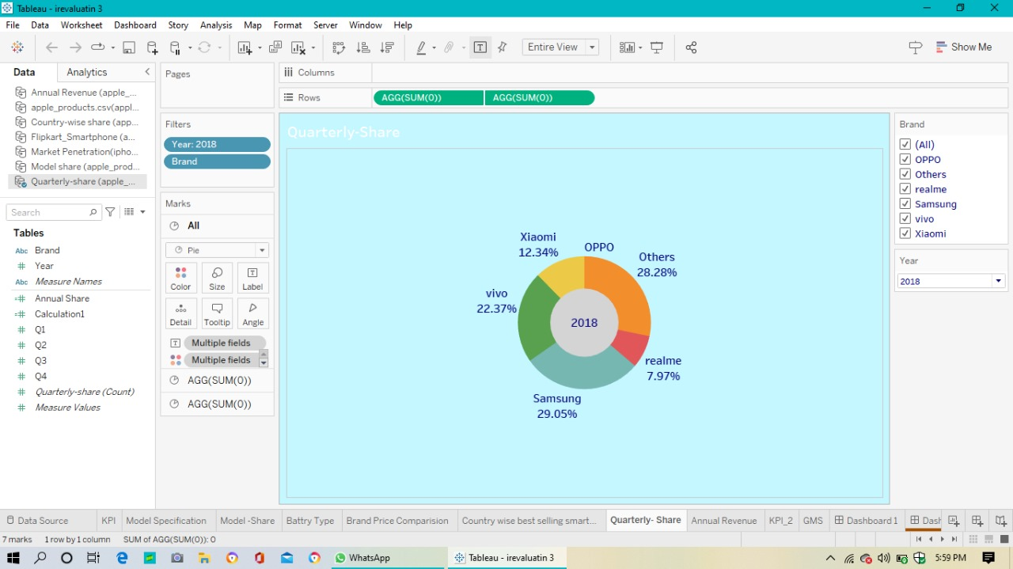

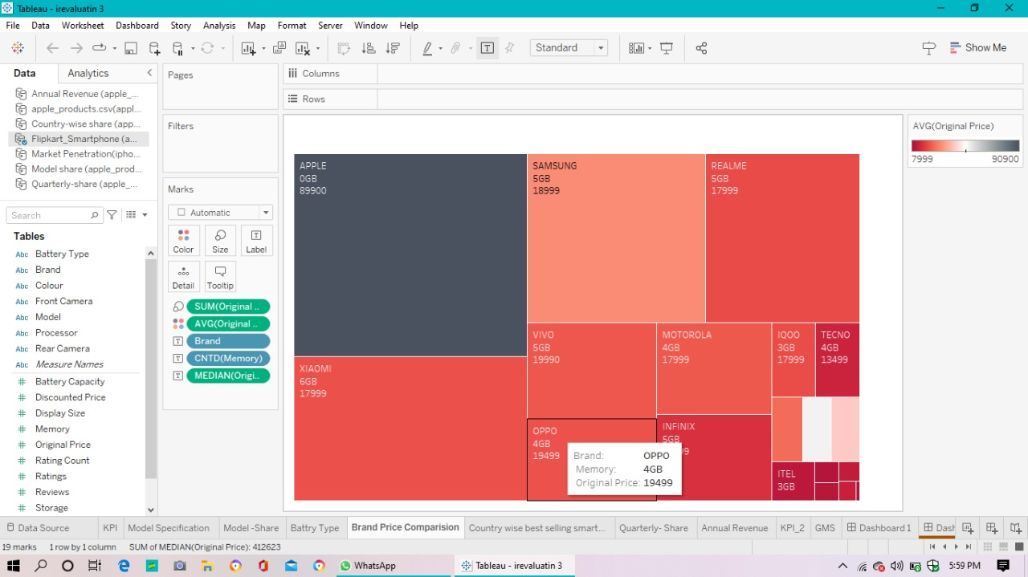

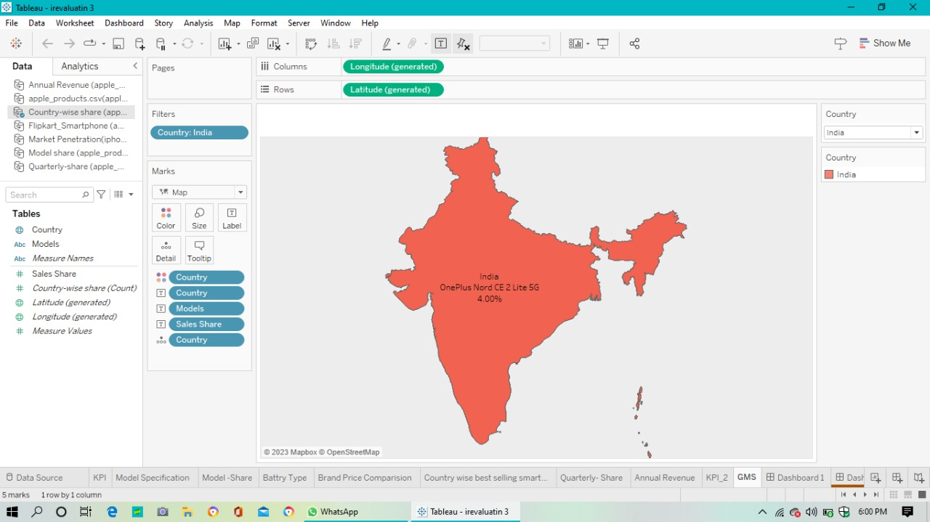

**4. ADVANTAGES & DISADVANTAGES**

* **ADVANDAGES**
* **Better Performance**
* **Easy To Use**
* **Timely OS Update**
* **Security and Privacy**
* **Third-party app security**
* **No Bloatware**
* **Family Sharing**
* **The Apple Ecosystem**
* **DISADVANTAGES**
* 18 mobile phone Disadvantages. Constantly Distracting
* Socially Distracting
* Battery Power Keeps RUNNING Out
* The workday never finishes
* Photos & video Mean No Privacy
* Spam
* Constant Expance

**5. APPLICATINS**

* **A Software application that runs under IOS, which is the operating system that powers Apple’s mobile devices.**
* **In most cases, any applications that runs on an iPhone also runs on an iPod and iPod touch.**

**6.CONCLUSION**

* **The main conclusion that can be drawn is we found to be the most interesting about Apple is now they are very innovative and early adapters. Apple is usually the first company to come out with a new product line before anyone else. This is very risky but it seems to be working to Apples advantage.**

* **7.FUTURE SCOPE**
* **Looking out 10 years, Apple of 2030 should continue to incrementally improve its hardware products and even introduce some new ones- but in a new twist, Apple will also expand its brand to develop a suite of bundled consumer services. That will be a big challenge for the tech giant, but also an opportunity.**